**Text File**

**Dashboards:**

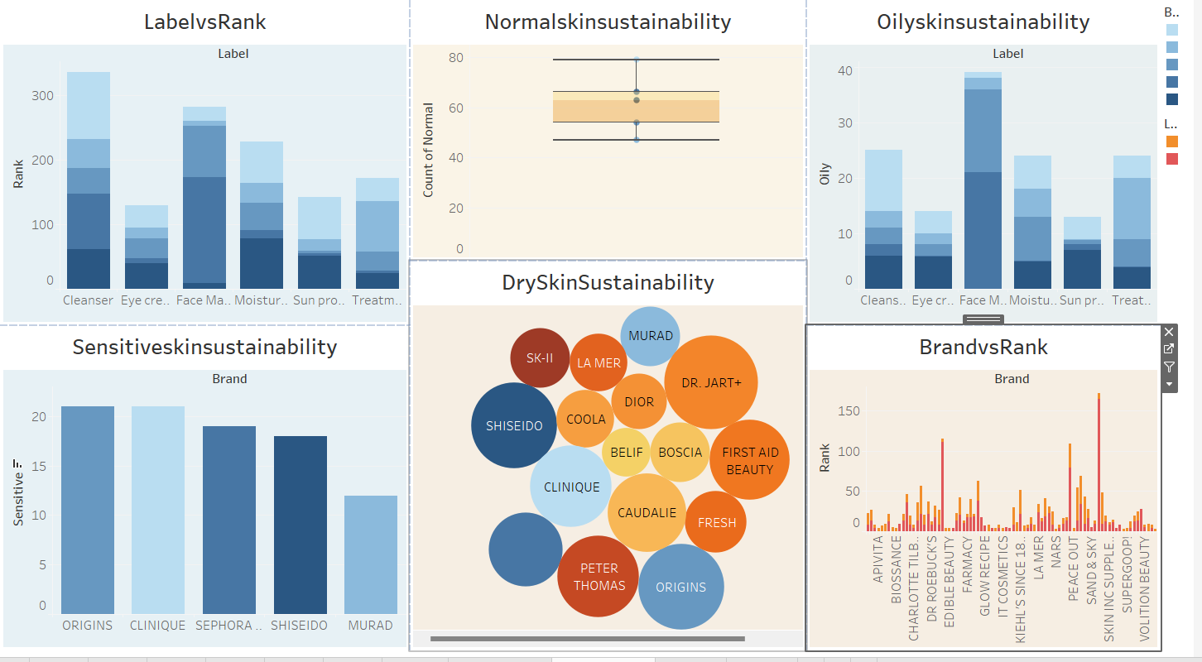

Dashboard link 1: <https://public.tableau.com/views/project_17422785859350/Dashboard1?:language=en-US&publish=yes&:sid=&:redirect=auth&:display_count=n&:origin=viz_share_link>

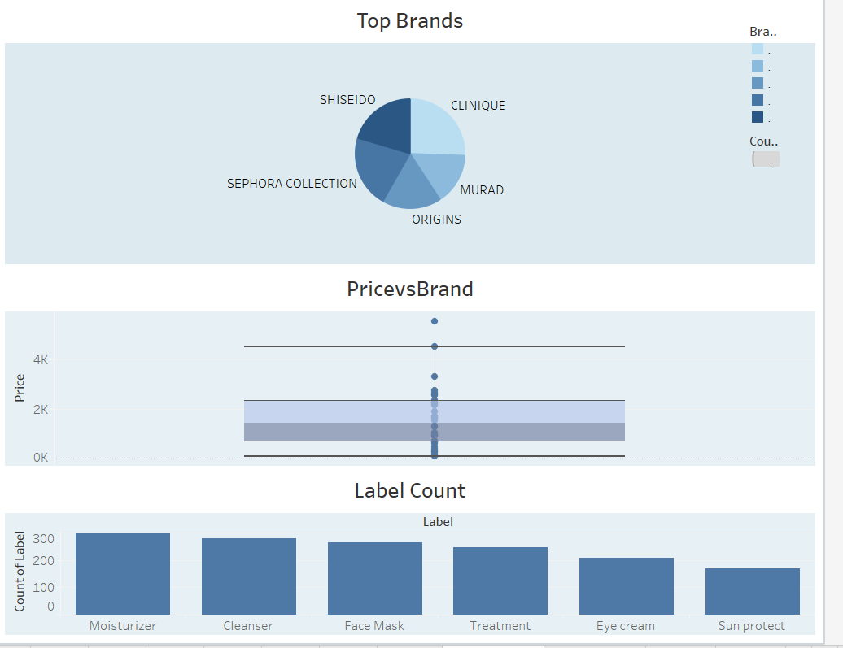

Dashboard 2 link: <https://public.tableau.com/views/project_17422785859350/Dashboard3?:language=en-US&publish=yes&:sid=&:redirect=auth&:display_count=n&:origin=viz_share_link>

Story public links:

Story 1 link: <https://public.tableau.com/views/project_17422785859350/Story1?:language=en-US&publish=yes&:sid=&:redirect=auth&:display_count=n&:origin=viz_share_link>

Story 2 link: <https://public.tableau.com/views/project_17422785859350/Story2?:language=en-US&publish=yes&:sid=&:redirect=auth&:display_count=n&:origin=viz_share_link>